Pattern analysis of olive grove distribution in the time series. A case study if Cartoceto (Italy)
S.Chiappini¹*, M. Balestra¹, MD Abdul Mueed Choudhury¹, E.Marcheggiani¹ and A. Galli¹
¹Department of Agricultural, Food and Environmental Sciences - Università Politecnica delle Marche. Via Brecce Bianche 10, 60131 Ancona,
{m.balestra, m.choudhury, s.chiappini}@pm.univpm.it; {a.galli, e.marcheggiani}@univpm.it

Keywords. Landscape ecology, olive orchard, tradition/innovation, landscape pattern
Abstract. For centuries, olive orchards have played a key role inside the municipality of Cartoceto, a small village in the north part of Marche Region, Italy. In this portion of land, the vast presence of olive trees steadily merged with the spirit of life of the small community and the history of the place was rooted for a long time. This cultural tradition of olive growing includes the surrounding municipalities also. In particular: Mombaroccio, Saltara, Serrungarina and Fano. Since 2004 the production area was awarded as “Geographical indication” (IG), linking clearly the product and its original place of production. This event was assigned the Protected Designation of Origin Brand’ according to strict technical production policie [1]. Actually the consortium includes the land and the producing farms is called Areale PDO of Cartceto.This study aims to provide shreds of evidence of how different olive groves, in the past, the olive trees mixed with crops (extensive type) and now the specialised olive orchards (intensive type), have shaped structural and functional features of the olive trees landscape. The main goal of the research is to assess landscape transformations in the Cartoceto's territory: from the year 1820, as reported in the historical "Gregorian Cadaster" map, up today. Changes within the set of selected orthoimages (1955, 1978, 1988, 2000 and 2019) by applying photo-interpretative skills allowed to draw-up thematic maps for each period in QGIS software by considering the most significant land use/land cover types. The work focused on the most considerable olive growing typologies, detecting six (6) different classes: isolated olive trees mixed with crops, olive rows mixed with crops, specialised olive orchards, intensive olive orchards, high-intensity olive orchards and garden olive trees. Changes and transitions among those different olive growing typologies were calculated for the temporal period taken into account. Besides, the evolution of the landscape in the study area, by processing a set of landscape metrics from Landscape Ecology, has been done concerning: number of classes, Landscape proportion, mean patch size, Hill's diversity number, edge density, patch density, land use diversity [2] were calculated.
Despite the natural reforestation of abandoned crop fields and the urban sprawl dynamic that have affected the study area in most recent decades, Cartoceto's territory still preserves different landscape typologies with high level of complexity. In short, two phenomena seem emerging: the flat areas have favoured the urban/industrial extension by leaving the cultivation of the olive tree relegated within the so-called "hobby farms for self-consumption"[3]. On the other hand, the hilly areas remained excluded from this intensive neo-urbanisation process. At the same time, a few olive farmers have led a kind of renovation of the olive sector implanting new olive orchards with a higher density of trees in some suitable arable lands.
The methodology applied in this study provided a large amount of information about land use/land cover distribution and changes within the study area over a considerable temporal interval. Furthermore, the analysis of landscape complexity through the metrics has proven effective for assessing the landscape structure. This comprehensive collection of data/information might open to building a geo-database for Cartoceto's territory, explicitly dedicated to managing the olive growing of this area and particular attention for identifying new arable land suitable for the extra-oil production.
References
[1] Marescotti, A.; Quiñones-Ruiz, X.F.; Edelmann, H.; Belletti, G.; Broscha, K.; Altenbuchner, C.; Penker, M.; Scaramuzzi, S. Are Protected Geographical Indications Evolving Due to Environmentally Related Justifications? An Analysis of Amendments in the Fruit and Vegetable Sector in the European Union. Sustainability 2020, 12, 3571. https://doi.org/10.3390/su12093571
[2] Venturi, M.; Piras, F.; Corrieri, F.; Fiore, B.; Santoro, A.; Agnoletti, M. Assessment of Tuscany Landscape Structure According to the Regional Landscape Plan Partition. Sustainability 2021, 13, 5424. https://doi.org/10.3390/su13105424
[3] Palazzo, A.L.; Aristone, O. Peri-Urban Matters. Changing Olive Growing Patterns in Central Italy. Sustainability 2017, 9, 638. https://doi.org/10.3390/su9040638

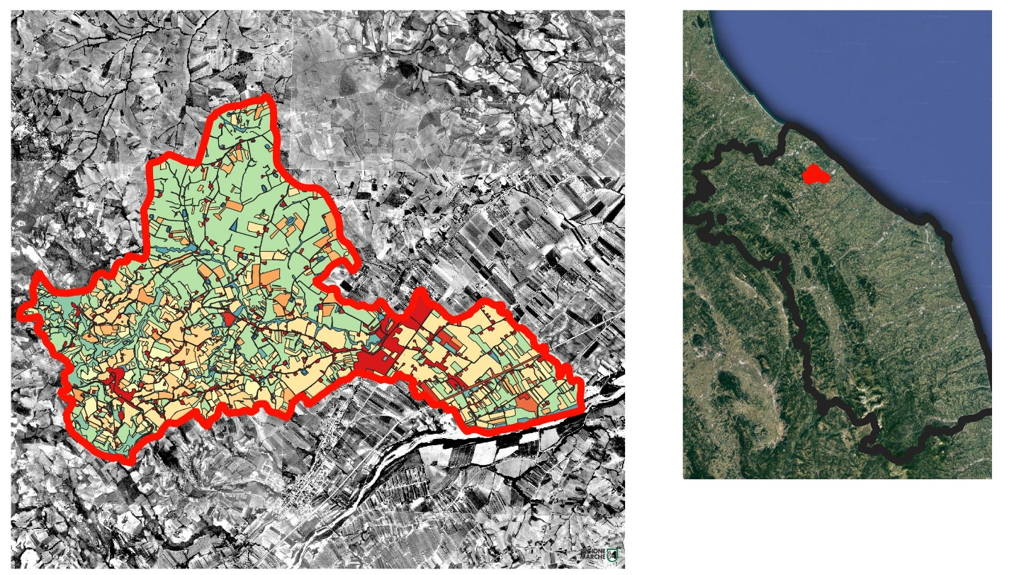
Figure 1 On the left an example of vectorizing different land use since 1978. On the right the location of the Cartoceto in the Region Marche, Italy

